CLONAR PARTIÇÕES INTEIRAS USANDO O COMANDO DD:

PARA SABER O NOME DAS PARTIÇÕES:

$lsblk -io KNAME,TYPE,SIZE,MODEL

OU SIMPLESMENTE:
$lsbk
__
EX:
DESTINO
sdd1
ORIGEM
sdc1
dd if=/dev/sdc1 of=/dev/sdd1 status=progress

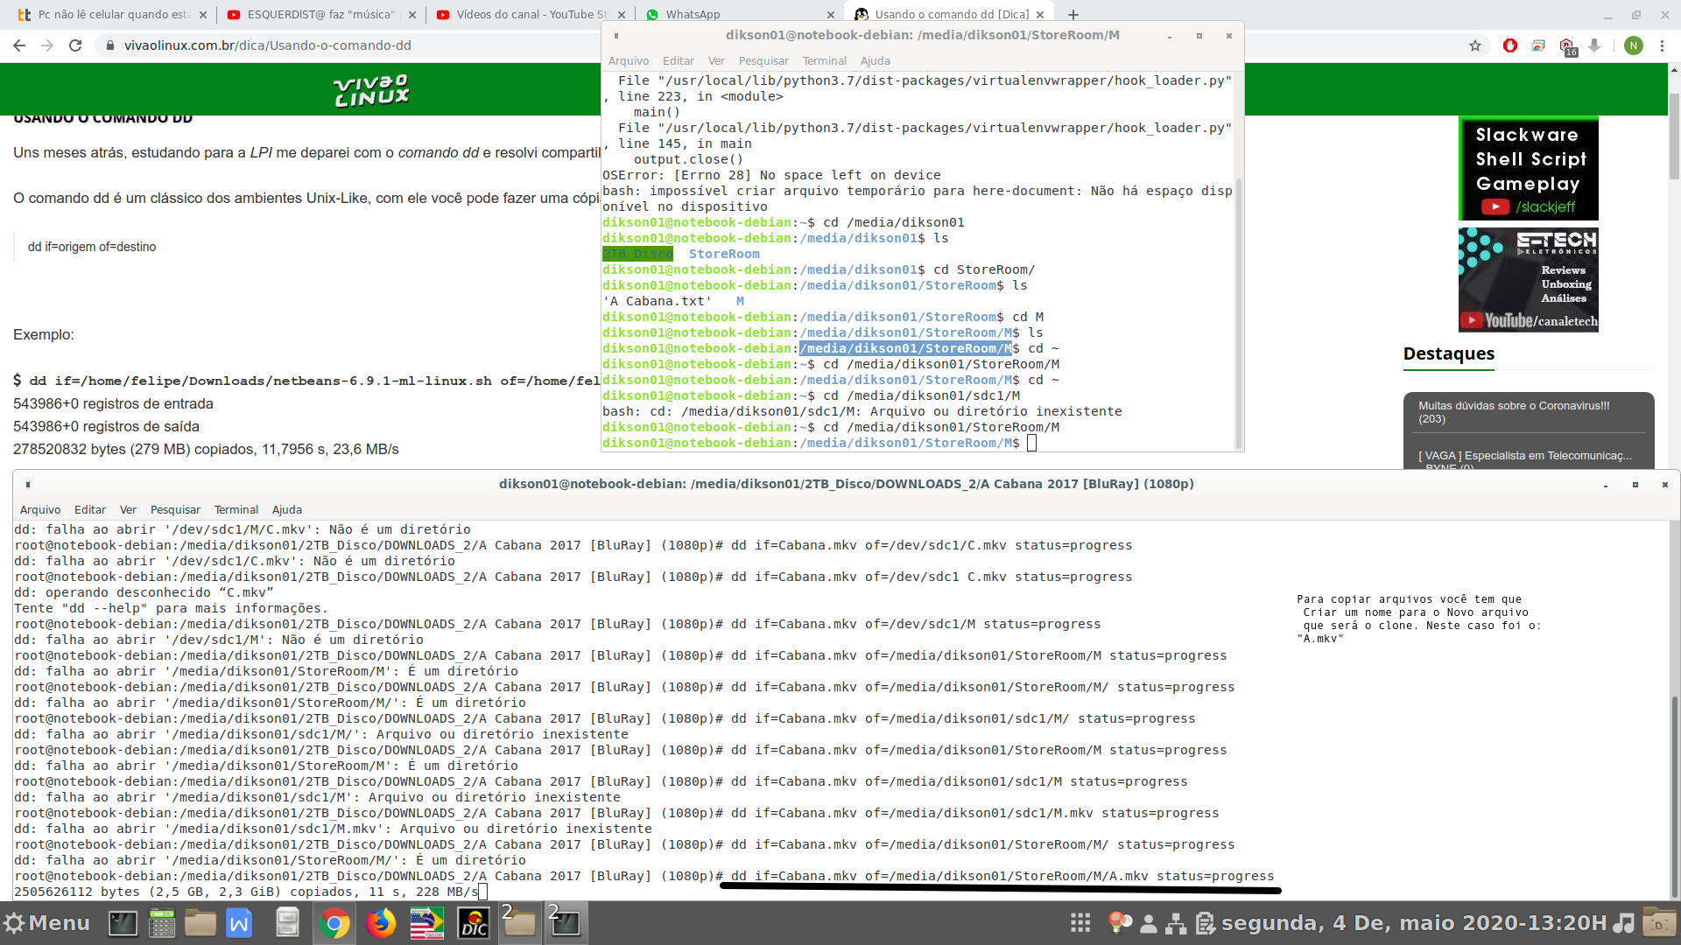
$dd If=/Origem of=/Destino status=progress

CASO PRECISE INSTALAR A FERRAMENTA DD:

Install DD Utility Tool
To install dd utility 1.4 on Ubuntu, and other Linux Systems, you will have to download the ddutility 1.4 package from the website and install it via Terminal commands.
CASO PRECISE INSTALAR O GDEBI (MAS ELE JÁ VEM NO CINNAMON):
sudo apt-get install gdebi
wget https://www.thefanclub.co.za/sites/default/files/public/downloads/ddutility_1.4_all.deb
CASO QUEIRA USAR O COMANDO PARA INSTALAR COM O GDEBI (MAS PODE USAR O DPKG):
sudo gdebi ddutility_1.4_all.deb

To uninstall and remove ddutility, run the following command:
sudo apt-get remove ddutility

FONTES:
https://sourcedigit.com/15565-install-dd-utility-tool-on-ubuntu-14-1014-04-linux-mint-systems/

https://atutoriais.com/linux/clonando-discos-usando-o-comando-dd/

